Worried About the Future of Manufacturing in Volusia County? Volusia County Managers Discuss the Future of Volusia County Manufacturing at Upcoming Volusia Manufacturers Association Meeting

Released on: April 16, 2010, 12:08 am
Author: WebWax.net
Industry: Small Business
The Volusia Manufacturers Association General Meeting for April 2010 will be discussing the future of manufacturing and other industries in Volusia and Flagler Counties.
When is the economy going to turn around and when are companies going to be hiring again? Nationally, unemployment rates were higher this February than in 2009 for 347 of the 372 metropolitan areas, lower in 21 areas, and unchanged in 4 areas, the U.S. Bureau of Labor Statistics reported today. Twenty-nine areas recorded jobless rates of at least 15.0%, while 2 areas registered rates below 5.0%. The national unemployment rate in February was 10.4%, not seasonally adjusted, up from 8.9% a year earlier. The top three industries with the most unemployed workers across the United States are construction, leisure and hospitality, and manufacturing at 22.7%, 12.6% and 11.9% unemployment, respectively (source: Volusia County Department of Economic Development ).
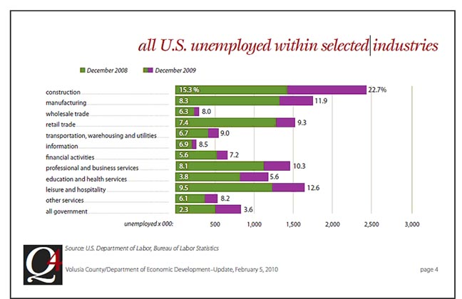
Volusia County, composed of Deltona, Daytona Beach, Ormond Beach, Edgewater and Deland, FL as the larger cities, has experienced higher than national average unemployment. In 2009, the yearly average unemployment rate for Volusia County was 11.0%, and is predicted to rise to a yearly average of 12.7% unemployment in 2010 (source: Volusia County, Department of Economic Development). Volusia County alone had 2009 unemployment rates of 11.8% for October; 12.4% for November, and 12.5% at the end of December, with the number of unemployed reaching 31,326 individuals. This unemployment rate is significantly higher than the national unemployment averages for the same time period in 2009: 9.5% for October, 9.4% for November, and 9.7% for December.
What does all of this mean for manufacturers in Volusia County and when are things going to get better? Volusia County Manager, Jim Dinneen, will be presenting his thoughts on the current state and future of manufacturing in Volusia County. Mr. Dinneen will also discuss the Volusia County Manufacturing industry; Manufacturing's impact on Volusia County; and what Volusia County is currently doing to assist local manufacturers in growing their businesses. Other topics for discussion will be the proposed sun rail, the Volusia County budget, Volusia County economic development and future planning, and how Volusia County is facing the current challenges this economy has introduced.
“Local Manufacturers need to attend this meeting,” said Jayne Fifer, President/CEO of the Volusia Manufacturers Association. “With the current challenges local manufacturers are facing, the Volusia Manufacturers Association is committed to providing opportunities for manufacturers to interact with local Government Officials so that productive ideas can be created collaboratively to benefit all industries.”
The Volusia Manufacturers Association (VMA) would like to open up attendance to this very important and informative meeting to all local manufacturers so that any Manufacturer desiring information can attend. This meeting will be held on April 22, 2010, at a new venue location, Indigo Lakes Golf Club at 312 Indigo Drive in Daytona Beach, FL, with networking starting at 5:30 P.M. and dinner and presentation at 6:15 P.M.
For more information about the Volusia Manufacturers Association or more information on how to attend this meeting, please contact Volusia Manufacturers Association or Jayne Fifer at 386.673.0505.
About Volusia Manufacturers Association:
The Volusia Manufacturers Association was founded in 1980 in Volusia County, Florida by manufacturers for manufacturers. Volusia Manufacturers Association provides information, education and networking opportunities to help manufacturers grow and succeed. VMA are made up of companies that range in size from one employee to over 500. If you are interested in joining the Volusia Manufacturers Association, please visit http://www.vmaonline.com.
Contact Information:
Jayne Fifer
President/CEO
Volusia Manufacturers Association
jayne.fifer@VMAonline.com
386.673.0505
Fax: 386.673.6663
Cell: 386.212.4003
www.VMAonline.com
~~~~~

Press release distributed via EPR Network (http://express-press-release.net/submit-press-release.php)

