Animal Online Store Launches New Wetsuit Range

Released on: May 07, 2010, 11:56 am
Author: Animal
Industry: Retail
Animal, the freesports apparel brand is proud to announce that their first ever wetsuit range has been launched on their online store.
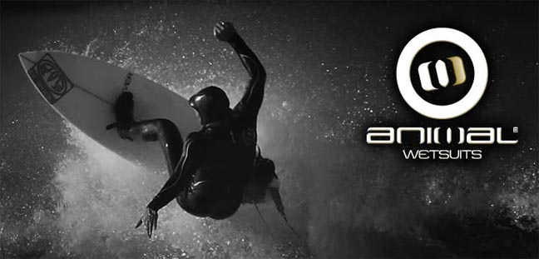
The Animal Wetsuit division is a new partnership formed with an external research and development team bringing together a wealth of experience, technical knowhow and manufacturing resources. This, when fused together with Animal's in-house design team has produced an exciting dynamic "newcomer" to the core surf market to create a variety of wetsuits to suit every condition, rider and level of ability. Technically, Animal wetsuits are up with the best of the market and utilise high tech neoprene materials and the latest construction methods.
Tim Metcalfe, Project Manager, commented: "As a newcomer into a technically led market, we knew we had to set our sights really high. Our aim was to develop a range of suits for the core British surfer, surfing British conditions and that meant using seriously good materials. We're fortunate to be working with one of the world's leading wetsuit manufacturers, which has given us access to the very latest in wetsuit construction and material technology."
The online Animal Outlet continues to have exclusive opportunities with up to 50% off prices for its shoppers as well as free delivery with all purchases, including orders for Animal clothing, free returns on all orders and a safe, secure shopping online experience.
Animal aligns itself as a lifestyle brand based around a number of core sports including surfing, windsurfing, kitesurfing, bodyboard, mountain bike, BMX, wakeboard, freeski, snowboarding and motorcross. Animal also sponsors key events across these sports and has a team of riders ranging from youth development through to professional.
About Animal
Established in 1987 in Poole, Dorset, Animal is one of the UK’s leading freesport brands specialising in the design, marketing and retailing of freesports influenced clothing, including Animal hoodies, technical clothing, footwear, luggage, eyewear, accessories and watches.
Actively involved within the freesports of surfing, snowboarding, windsurfing, kitesurfing and mountain biking, Animal sponsor high profile riders and operate a number of academies and camps giving newcomers and experienced riders the opportunity to pursue their chosen sports further.
For more information, please contact:
Jo Gregory
PR coordinator
Animal
Animal House
Vanguard Road
Poole
Dorset
BH15 1PH
01202 441174
www.animal.co.uk
~~~~~

Press release distributed via EPR Network (http://express-press-release.net/submit-press-release.php)

