Biogas Set To Power Our Homes


Released on: May 01, 2010, 3:58 am
Author: Build A Biogas Plant.com
Industry: Energy
Biogas was once the domain of third world countries, but people at build-a-biogas-plant.com show that as energy costs skyrocket and new biogas designs come on the market, even people in a Western city can benefit from a biogas digester.
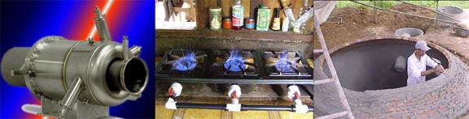
Biogas is produced when organic matter is broken down by bacteria. The organic matter could be cow dung, but equally it could be the food scraps we throw away every day in our homes. Instead of these scraps going to landfill, they could be put far better use and go into a digester to produce biogas.
The biogas is made up of a large amount of methane, and methane is the important ingredient in biogas. Like natural-gas, biogas can be burned and used to heat water, create lighting or run our cooking stoves and it can even be used to run generators which produce electricity.
“We have been overwhelmed by the response to access the biogas information,” said Simon, a staffer at www.build-a-biogas-plant.com. “Our digester designs cater for individual’s household use, but larger systems are also available for communities, farms and other commercial businesses”.
In the United States alone, billions of tonnes of manure are produced each year by millions of cattle, pigs and chickens. Imagine how much electricity would be produced if all this dung was processed in biogas digesters? Not only would it replace a lot of natural gas but the residue makes a wonderful fertilizer (often better than commercially prepared products).
Build-a-biogas-plant.com was developed to provide people with information and a wide choice of biogas digester designs. The site offers reports, articles, research material, plans, designs and construction detail so people can build their own biogas digester.
Contact Details: 27 Forecrain Street, Canberra Australia
http://www.build-a-biogas-plant.com

~~~~~

Press release distributed via EPR Network (http://express-press-release.net/submit-press-release.php)

