Boomers Circumnavigate Lake Superior With BeneVia®, Proving Active Lifestyles Enhance Healthy Aging
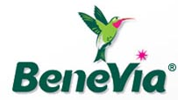
Released on: May 25, 2010, 05:14 am
Author: HealthSpan Solutions
Industry: Healthcare
HOUGHTON, Michigan – (May 25, 2010) - Baby Boomers Mike Link and Kate Crowley, currently undertaking one of the most demanding adventures ever conceived for people in the Boomer generation, a 1,600-mile circumnavigation of Lake Superior, are supplementing their demanding daily regimen with BeneVia®, a popular fruit-based healthy and therapeutic nutrition beverage especially formulated to meet the energy, nutrition and health needs of Boomers, now entering their 50s and moving into their sixties and seventies.
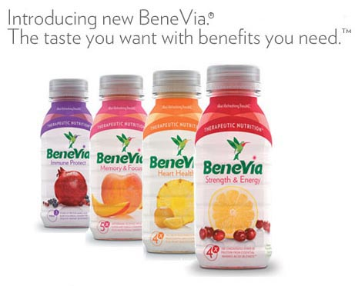
An Inspirational Boomer Challenge
Healthspan Institute and BeneVia were selected as the Official Therapeutic/healthy Nutritional Sponsor for the Full Circle Superior expedition based on the strong clinical evidence these products provide for managing active lifestyles. The circling of Lake Superior on foot will stretch across five months and all states and the Canadian border surrounding this lake, which represents 20% of the Earth’s fresh water source. BeneVia Strength & Energy drink is used daily to provide the nutritional energy, strength and recovery needed for each day of the walk.
Link and Crowley are circumnavigating Lake Superior on foot, hiking as close to the shoreline of the Lake as possible. Along the way, they are recording important data about the ecology of the shoreline, the people and places they encounter, the streams they cross, their nutritional intake, and the adventure of a lifestyle as focused nomads. With other dedicated professionals and organizations, they are speaking and presenting along the way, publishing articles, writings and thoughts on their website,www.fullcircle.org, to share their discoveries, their insights and feelings and dreams. They are also blogging weekly at www.goBeneVia.com to share their story.
Nutritional Support Key to Active Lifestyles and Physical Challenges
To keep up with the demanding physical and mental regimen required for the 1,600-mile, expedition leader Link, a retiree, and “motivator in chief” Crowley, 60, on the cusp of becoming a Boomer, are calling on HealthSpan Institute’s BeneVia, which is formulated to address the four biggest issues facing people 60 and older: lack of muscle strength and energy, loss of memory and learning, cardiovascular health issues and the need for protection from infections with normal immune response.
“Full Circle Superior is an ideal stage to demonstrate the benefits of BeneVia,“ said John Troup, CEO, HealthSpan Institute, whose organization formulated the popular therapeutic nutrition drink. “Mike and Kate daily face the four challenges that BeneVia addresses. We are very pleased that they are including BeneVia as part of the support program that is making the entire expedition a success. In this week of National Senior Health & Fitness, Mike and Kate are an inspiration to all of us and provide a great example that active lifestyles are important and that aging need not slow us down.
“BeneVia is playing an important role in fortifying, energizing and hydrating. Mike and Kate and will increasingly become more valuable to them as they begin to experience the physical and mental demands their undertaking require. For BeneVia, the Full Circle Superior expedition is a perfect stage to demonstrate what our healthy, therapeutic nutritional beverage can do, particularly under very demanding circumstances. With such a demanding physical schedule, BeneVia will provide the energy to help maintain muscle strength and activity, provide key nutrients to keep them going and staying healthy and the mental focus to stay on track.
Partnership for Healthy Aging and Nutritional Support
Free online product samples can be requested this week as part of the company’s sponsorship of National Senior Health and Fitness Day on May 26. To request a free sample of BeneVia and receive a free book The Science of Staying Young go towww.TryBeneVia.com.
BeneVia is one of the eight primary sponsors of Full Circle Superior, which include leading medical, fitness, outdoor apparel and gear and media organizations.
About BeneVia
BeneVia is a fortified fruit juice beverage that tastes great and is less filling than creamier “shake-based” nutritional drinks. BeneVia is fat-free, low-calorie, found in the adult nutrition category and provides a superior and clinically supported protein blend for aging health.
The four varieties of the BeneVia product line contain nutrients which have been clinically tested and proven to aid in managing the four most common health conditions faced by boomer consumers: strength and energy, memory and focus, heart health, and immune protection.
More information: www.goBeneVia.com or 501-663-3001.
For free samples and book: www.TryBeneVia.com through May 28, 2010.
# # #
More information: Taylor Carter , HealthSpan Solutions, 501-663-3001
~~~~~

Press release distributed via EPR Network (http://express-press-release.net/submit-press-release.php)

