Compton & Woodhouse Celebrate 25th Anniversary with a Limited Edition John Bromley Figurine


Released on: May 21, 2010, 12:36 pm
Author: Compton & Woodhouse
Industry: Retail
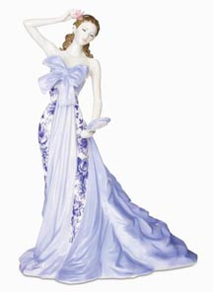
One of the UK's leading retailers of jewellery and prestige collectables, Compton & Woodhouse, have announced plans to celebrate 25 years in the industry by releasing a limited edition commemorative figure.
World-renowned sculptor John Bromley is the talented artist commissioned to create a stunning limited edition piece made exclusively for the prestigious occasion.
Compton & Woodhouse believe that an anniversary is a perfect cause for celebration, and the brand who have provided beautiful gifts, fine jewellery, collectable bears, discounted diamonds and luxury items for the home for a quarter of a century are delighted to celebrate such an occasion with their loyal and valued customers.
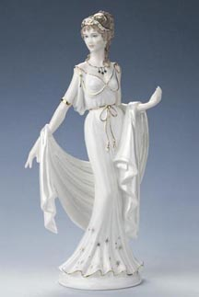
Since 1985, Compton & Woodhouse have been providing the absolute best in unique figurines and exclusively commissioned collectables, becoming an established household name in the process, and have collaborated with the world's most celebrated artists and craftspeople.
John Bromley is one such sculptor and has expressed his delight at being chosen for such a momentous occasion; "I've worked with Compton & Woodhouse since the very beginning, and it's a great privilege to help them celebrate their 25th year."
Bromley recently celebrated an anniversary of his own and was eager to make his latest piece for Compton & Woodhouse extra special; "The piece we've created not only marks an important milestone for the company, but also means a lot to me personally. I'm extremely fortunate to earn a living doing something I love and, though I can hardly believe it, I've now been sculpting for 50 years. I knew instantly that this figurine must be something really meaningful, and inspiration came from a source very close to me – my own granddaughter."
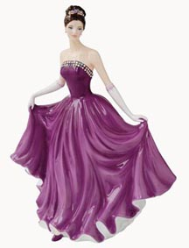
The Compton & Woodhouse brand has grown through innovation across the years, starting out as a print-driven company covering home catalogues, national press and woman's magazines before evolving into a 21st century brand retailing online and most recently through a television shopping channel.
Mark Dugdale, Compton & Woodhouse's Chief Executive, looks forward to another successful 25 years trading:
"We have had a fantastic 25 years, and want to thank all of our customers, staff and artists that have made all of this possible. We are delighted to be working with John Bromley for our 25th anniversary and look forward to many more years in business."
From the very beginning, Compton & Woodhouse's aim was to bring people the very finest selection of figurines and collectables. Royal Staffordshire figurines are instantly recognisable for their smooth, flawless finish and impeccable attention to detail. John Bromley's creation, titled ‘Hannah', has been crafted by hand using time-honoured techniques. The care and attention is second to none and the 2,500 special edition figurines each arrive individually numbered and stamped with Royal Staffordshire's authenticity and signed by John Bromley.
Compton & Woodhouse offer a guarantee of excellence across all prestige collectables, diamond rings and other pieces of fine jewellery. Their reputation for providing classic design, quality, artistry and supreme craftsmanship has led them to become the UK's leading fine jewellery and collectables direct retailer. Find out more at www.comptonandwoodhouse.co.uk.
Contact Details: Compass House, 22 Redan Place, London W2 4SA, 020 7313 6400
~~~~~

Press release distributed via EPR Network (http://express-press-release.net/submit-press-release.php)

