DealToWorld.com–Unbelievable Service

Released on: May 13, 2010, 6:13 am
Author: Bill Zhang
Industry: Electronics
DealToWorld.com is an amazing platform especially for the gadget lovers and here one can get a number of attractive gadgets at really surprising prices. The main advantage of using this service is that the shipping is absolutely free. This is the main reason why most people are opting for DTW. It is gaining attention among several people not only in one country but throughout the world. The unbelievable services of DealToWorld amaze the customers and of course it is one of the best services available.
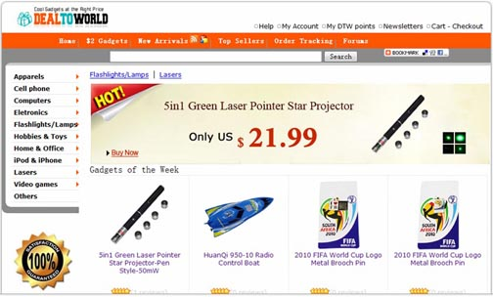
Unbelievable price
The prices offered by DealToWorld are really surprising as one can get free shipping on almost all types of orders. The price range is really competitive and moreover, it provides the cheapest price. There is a huge variety of accessories and apparels and one can choose any one depending upon the choice and interest. DTW has large warehouse through which they supply various items or products directly at the mailing address. The interesting thing about DTW is that the shipping is absolutely free and this is the reason most customers are taking interest towards this amazing online store. Shipping is completely free because they use SingPost Airmail. DTW has partnership with SingPost and this is how they deliver all the orders free from shipping. The SingPost is very fast and one can be assured of delivery within 10 working days.
Unbelievably fast
There are basically two methods for the delivery of package, one is via air mail and second is via EMS express. EMS Express is basically for those who want urgent or bulky deliveries. Opting for EMS delivery method one can get the package within 4 to 5 working days while the normal delivery method takes around 10 working days. It is an amazing super fast service provided by DealToWorld and it guarantees super fast delivery. There are several countries to which DTW provide EMS Express service. One can see the main countries where it provides EMS service on the home page of website.
High discounts on bulk orders
DealToWorld also provides huge amount of discounts to the customers who want to purchase bulk orders. It is the best option for people as they can get heavy discounts in this way. One needs to enter a specific coupon code in order to purchase in bulk. Coupon code is given in the website and thus one can see the code from there and use it to activate bulk purchase. Bulk orders are also provided for international countries without any shipping charge.
Payment options
There are several payment options available for the convenience of customers but it is always recommended to the customers that they should opt for Pay pal payment procedure. Pay pal is the most secure and easiest way to shop online. There are several benefits of pay pal as it does not display any kind of financial information like in credit cards. Making an account in pay pal is quite easy and everyone can do it without any help. So, just enjoy the amazing service of DealToWorld of small and powerful gadgets.
Recommended Videos:
a.http://www.youtube.com/watch?v=eoqI_sd30W4
b.http://www.youtube.com/watch?v=zcgNO25pDkc
c.http://www.youtube.com/watch?v=CAiAHwCqZFY
d.http://www.youtube.com/watch?v=usQltZ_RAVM
f. http://www.youtube.com/watch?v=ZEDKQasevBc
g.http://www.youtube.com/watch?v=4glswkpzn6Y
Contact Details: http://www.dealtoworld.com
zhangzhengr@gmail.com

~~~~~

Press release distributed via EPR Network (http://express-press-release.net/submit-press-release.php)

