Debenhams Announces Official Retail Partnership With Sex And The City 2

Released on: May 27, 2010, 05:34 am
Author: Debenhams
Industry: Retail
Debenhams has announced that it is to become the official retail partner for the upcoming film, Sex and the City 2.
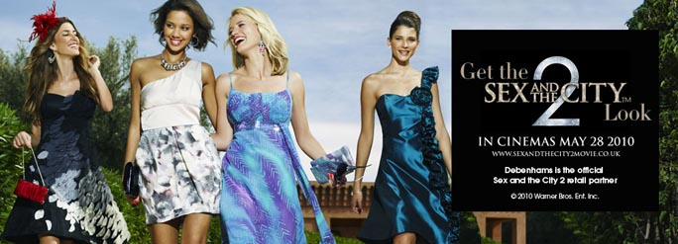
Debenhams was the official retail partner for the first 'Sex and the City' movie, and is now pleased to announce its sponsorship of the new film as well. The sponsorship deal has been seen as the ideal partnership for the department stores group because Debenhams provides fans with a one stop shop for 'Sex and the City' products and it is therefore a perfect match made in retail heaven for any aspiring Miranda, Carrie, Samantha or Charlotte.
To celebrate the partnership Debenhams is also offering four lucky customers the chance to win a trip to New York in conjunction with the eagerly anticipated 'Sex and the City 2' movie which is due for general release in the UK on 28th May.
The prize includes 4* hotel accommodation and $1000 spending money. Debenhams card holders will also be given the opportunity to win 50 'Sex and the City 2' goody bags through a free prize draw competition.
Suzanne Harlow, Debenhams Group trading director commented, "The partnership makes perfect sense for Debenhams as we are the only high street retailer that provides customers with the complete Sex and the City experience under one roof".
Debenhams designer ranges cater for Carrie's fashionista style, Samantha's sexy looks, Charlotte's ladylike chic and Miranda's power dressing image. With designer ranges, concessions, a beauty hall with all the major luxury beauty brands, and a shoe department which will make any Carrie-wannabe go weak at the knees; Debenhams is thrilled to sponsor the hotly anticipated new release.
The campaign will be launching on 17th May 2010, in combination with press and digital advertising as well as in store and online, making accessible the style of New York’s most fashionable friendship and enabling anyone to get that perfect Sex and the City 2 look.
Details of the competition can be found on the Debenhams website.
About Debenhams:
Debenhams is a leading department stores group, and has a strong presence in key product categories including women's fashion, such as dresses, women's shoes, dresses, bikinis, jeans, men's clothing, home ware, make-up, health and beauty, accessories, perfume, lingerie and children's wear.
For more information and images, please contact:
Lizzie Singleton
Debenhams Press Office
33 Wigmore Street
London
W1U 1QX
020 7529 0121
www.debenhams.com
~~~~~

Press release distributed via EPR Network (http://express-press-release.net/submit-press-release.php)

