Debenhams Reveals The Great Bikini Cover-Up Contradiction

Released on: May 11, 2010, 5:08 am
Author: Debenhams
Industry: Retail
Debenhams has discovered that with the 'staycation' trend still going strong, as many people continue opting for a budget-saving British holiday this year, 80% of women say they would not wear a bikini when heading to a British beach for their summer break - despite 91% saying they always wear one abroad.
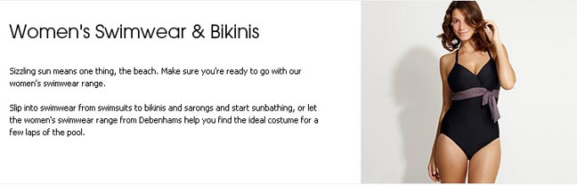
The leading department store uncovered the great cover-up contradiction when they asked customers if holidaying in Britain affected their usual choice of swimwear, and identified the reasons for this newfound modesty among those staying at home for their break.
No longer the preserve of older women, less revealing swimwear options such as the skirted swimsuit are enjoying a surge in popularity among women of all ages, with a rise in sales of more than 112% year-on-year compared to skimpier styles such as bikinis.
Sasha Nagalingham, Swimwear Buyer for Debenhams, explained: "Despite a reputation for leaving inhibitions at the door in places like Alicante and Antigua, traditional British reserve takes over in Bognor and Brighton - its geographical modesty."
The number one reason cited by women for their preference was the potential embarrassment of being spotted in skimpy swimwear by an acquaintance, with 51% choosing less revealing beachwear for staycations. The second most popular reason, among 42% of respondents, was the presence of more children on the UK's beaches.
These reasons, among others, also saw 100% of women questioned saying they would never go topless on a British beach, compared to 54% who admitted to going topless when abroad.
Sasha added that there are regional variations in the trend, based on sales of swimwear recorded at Debenhams stores across the nation. "Sales of skirted swimsuits indicate that Blackpool is the most modest town in the UK, having sold more units there than anywhere else," she said.
"Although low temperatures may be a contributing factor, Aberdeen was the second most modest with Cardiff coming in as the least modest area in the UK."
The top 10 modest towns in Britain, according to Debenhams swimwear sales, were found to be Blackpool, Aberdeen, Torquay, Bristol, Brighton, Hastings, Eastbourne, Chester, Bolton and Reading.
Observing the trend, Sasha said: "The return of the staycation has simultaneously sparked a return to Victorian values; judging by sales of the skirted swimsuit, British beaches will look like 50s picture post-cards this summer."
ENDS
Notes to Editors:
About Debenhams:
Debenhams is a leading department stores group, and has a strong presence in key product categories including womens fashion, such as summer dresses, womens shoes, dresses, bikinis, jeans, home ware, make-up, health and beauty, accessories, perfume, lingerie and children's wear.
Contact Details: Lizzie Singleton
Debenhams Press Office
*33 Wigmore Street
London
W1U 1QX
020 7529 0121
http://www.debenhams.com/
~~~~~

Press release distributed via EPR Network (http://express-press-release.net/submit-press-release.php)

