Hazmat Training Comes to St. Louis


Released on: May 07, 2010, 9:03 am
Author: Environmental Resource Center
Industry: Environment
May 7, 2010- When workers handle hazardous waste or ship hazardous materials, training is not just a good idea, it’s the law. According to the EPA, workers who handle hazardous waste must be trained annually, and the federal DOT requires that workers involved in the shipment of hazardous materials be trained at least every three years.
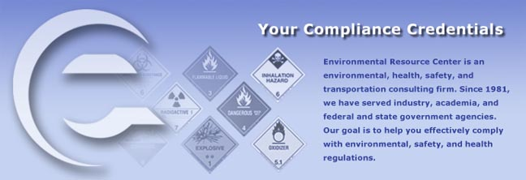
Environmental Resource Center, the leading provider of environmental and safety training, will present the mandatory training in St. Louis at the Holiday Inn – St. Louis Airport on May 11 – 13, 2010. Training begins at 8am and ends at 5pm each day.
Hazardous Waste Management: The Complete Course will be taught on May 11 and 12.
Hazardous Materials Training: The Complete Course will be taught on May 13.
Registration for the training is available by calling 800-537-2372 or at http://www.ercweb.com/classes.
Now in its 28th year, Environmental Resource Center trains not only thousands of industry personnel every year, the company also trains personnel from most of the state and federal agencies that enforce the regulations.
Contact Details: Malia Campbell
Environmental Resource Center
919-469-1585; Fax: 919-342-0807
mcampbell@ercweb.com
http://www.ercweb.com
~~~~~

Press release distributed via EPR Network (http://express-press-release.net/submit-press-release.php)

