House of Fraser Makes Lancôme Available Online


Released on: May 27, 2010, 05:17 am
Author: House of Fraser
Industry: Retail
House of Fraser, premium department store, has announced the introduction of the Lancôme makeup and skincare to its online range.
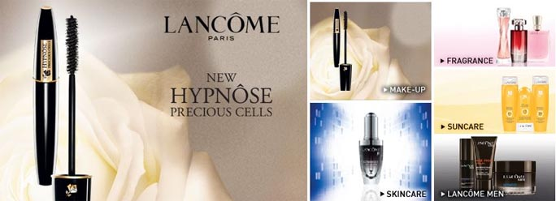
The launch of the Lancôme collection through the House of Fraser website increases the groups range of top beauty brands and means that customers can now easily find Lancôme alongside some of the biggest and most exclusive names in women's makeup and skincare.
Harnessing knowledge from L'Oreal's haircare technologies and its groundbreaking skincare range (Absolute Precious Cells), Lancôme Advanced Research Laboratories have confirmed a link between lash structure and epidermal stem cells and their role in determining the condition of lashes. At the heart of lash follicles are numerous stem cells, which are essential for hair growth and structure. But the structure and condition of lashes can be affected daily by people's beauty routines, and this calls for advanced care.
The new Lancôme mascara regenerates lash condition and achieves lash-by-lash volume and length as well as visibly denser lashes. The Hypnôse Precious Cells mascara features a helix shaped brush with two flat sections to capture the formula and bathe lashes; and two ridges for lash fringe definition, magnified volume and lengthening. Lancôme now offers mascara that is capable of protecting the lashes, while offering an astounding makeup result for women across the world.
In addition to the Lancôme Hypnôse Precious Cells, houseoffraser.co.uk also offers Génifique, a skincare product that helps skin rediscover its beauty potential, harnessing the beauty programmed in the genes. The innovative luxurious formula upon application, instantly envelopes the skin and optimises its environment. The velvety texture delivers the promise of high performance for younger looking skin.
Lancome is another major brand to add to the House of Fraser beauty range and forms part of the wider strategy to expand on the number of top beauty brands all available under one roof. The move follows the recent announcement that Elemis and the Japanese cosmetic company Shiseido were added to the website.
ENDS
Notes to Editors:
About House of Fraser
House of Fraser is a department store group with 61 enviable locations across the UK and Ireland and a fully transactional website. As one of the best known names on the high street, House of Fraser has presented customers with an unrivalled nationwide department store for more than 160 years. The company was acquired by the Highland consortium in November 2006 marking the beginning an exciting new chapter in its history. The group has annual sales in excess of £1.25bn and employs 6,500 House of Fraser staff and 10,000 concession staff through 5 million sq ft of selling space. House of Fraser also stocks Lancôme skincare, Lancôme makeup and fragrances.
House of Fraser media contact:
Rea Shahroudi
Online Acquisitions Manager
House of Fraser
27 Baker Street
London
W1U 8AH
020 7003 4102
www.houseoffraser.co.uk
~~~~~

Press release distributed via EPR Network (http://express-press-release.net/submit-press-release.php)

