IB Diploma, Truly Global!


Released on: May 07, 2010, 9:29 am
Author: IC School
Industry: Education
London, May 2010 - What is the educational qualification that is accepted in over 138 countries and across all the reputed universities of the world? The only correct answer to this question is the IB Diploma. An IB Diploma in your educational resume ensures a favourable passage through most of the stringent conditions set by the University of your choice for your acceptance. Now you can study for your IB Diploma in London with the Geneva-based International Baccalaureate recognising London school International Community School for delivering the prestigious diploma from September this year
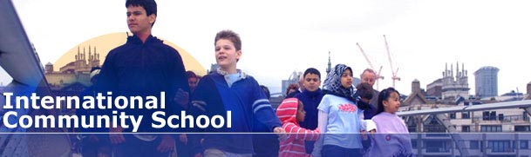
"I was very insistent that my children have a truly global education. That is why we decided against sending them to the local public school in York, though it is well-known for providing education of fairly good standards. But I wanted my children to have school diplomas that are head and shoulders above the rest", says Peggy Thornton, a proud mother whose son is preparing to begin his IB Diploma next term. British parents are increasingly ensuring that their children reap the benefits of a quality private education. "But there is a new category of emerging parents who are globe-trotters themselves. So they want to ensure that if they have to get their children to move around with them, they should be in an education system which is offered in more countries. I think this has been a crucial factor in the popularity of the International Baccalaureate course", says Rosie Harrow, a Surrey school administrator.
The International Baccalaureate organisation works out of Geneva and has an evolved curriculum that draws from the best practises of educational systems across the world. The course is structured in such a manner that every student passing the IB Diploma course is better prepared than students from other systems for the more challenging academic demands of the University. In fact, there are three IB courses that cater to students between the age group of 3 and 19, ensuring a holistic academic experience through their formative years. An international school London has to offer ensures that the student also gets a taste of metropolitan way of life. Besides, more importantly, anIB Diploma Central London ensures that a student aspiring to continue their University education has access to some of the leading London colleges under the University of London.
Contact Details: 21 Wilbury Grove
Brighton & Hove
United Kingdom
independentjournalismproject@gmail.com
http://www.icschool.co.uk/
~~~~~

Press release distributed via EPR Network (http://express-press-release.net/submit-press-release.php)

