New You Boot Camp Launches Mid Week And Weekend Fitness Breaks


Released on: May 07, 2010, 8:50 am
Author: Sunny Moran
Industry: Healthcare
A-listers have been privy to the New You Boot Camp secret for a while, and now with the launch of New You Boot Camps –MID WEEK AND WEEKEND BREAKS, we can all join the elite to kick start our fitness and weight loss even if we have limited time and budget!
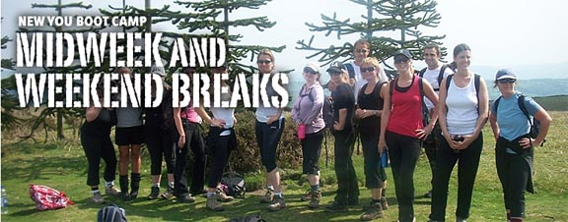
Join the likes of Hillary Swank, Oprah Winfrey, Barbara Streisand, Renee Zellweger, Gwyneth Paltrow, Cindy Crawford, Cat Deeley, Patsy Kensit and even curvy Catherine Zeta-Jones who are rumored to have enrolled in Boot Camp’s to get that A-list body.
New You Boot Camp have at last launched the long awaited mid week and weekend booster breaks. We are offering a 2 night mid week break and a 3 night break which is over the weekend to fit in with your busy schedules. Both breaks are open to ladies and gentlemen so why not bring your partner along too!
The Booster Boot Camp have been especially formulated for those looking for a kick start into fitness and a healthier lifestyle, and for anyone who is beginning a new journey to discover the,“New You”.
You will experience a taster of our famous globally recognised, week long, residential boot camps. Perfect for boot campers that can’t find time in their schedules but still would like the challenge of New You Boot Camp. The boosters are also perfect for returning clients who need a further helping hand to keep them on track to their healthier lifestyle.
The New You Boot Camp Mid Week Breaks are Nestling in a private valley at the end of a quiet lane, our Manor Estate is a unique hideaway between the rolling Shropshire Hills and the beautiful Wenlock Edge, providing the ultimate in rural retreats. Here, you really can wake up to the peaceful sounds of birdsong and rustling leaves, then open your door onto our 500 acre estate which includes idyllic pasture and beautiful woodland, perfect for an afternoon spent exploring. Singles, twins, doubles and triples are offered at this beautiful rural manor estate just west of Birmingham. Prices start at only £425pp and range to £525pp.
The New You Boot Camp Weekend breaks ‘Back To Basics Boot Camp’ Bunkhouse is a newly converted stone barn graded 5 star, situated on high Mynnedd Llangattock above Crickhowell in the Brecon Beacons National Park, Wales. We are blessed with having the Brecon Beacons National Park and the Gower Coastline on our New You Boot Camp doorstep. These are both wonderful natural adventure activity playgrounds. Not many places in Europe can boast a mountain wilderness and a coastline designated as an Area of Outstanding Natural Beauty within 30 miles of each other.
Let’s get this clear it’s a New You Boot Camp without the frills... if you are looking for an affordable New You Boot Camp, and don’t mind basic ‘Army' style bedrooms, communal bathrooms/showers, washing your own dishes, then keep on reading... if you can’t bear the idea of sleeping in a bunk style room sharing communal then come and see us at our mid week breaks at our rural estate. Prices start at £495pp
Days at the New You Boot Camp are broken up into hourly lessons and include sunrise runs, hiking, walking, boxing, military activities and relaxation sessions to name a few.
• 4 days and 2 nights accommodation on mid week and 4 days and 3 nights accommodation at the weekend
• Up to 12 Hours of cardiovascular exercise/pt training per day from World class Military Trainers.
• All delicious meals and delicious snacks freshly prepared by our own New You Boot Camp chefs.
• Unlimited drinks that include water, selections of fruit teas, selection of detox teas and green teas.
• One to one expert training advice – tips and a programme for you to take home.
• Relevant equipment for activities (e.g: mountain bikes & helmets, abseiling harnesses, fit balls, exercise mats, boxing pads and gloves).
• Extreme boot camp experience activities - Lifetime achievements!
If you are travelling alone you can still book a twin space and we will endeavour to pair you with someone with a suitable background.
For more information including boot camp dates visit http://www.newyoubootcamp.com
Contact Details: Sunny Moran
sunny@newyoubootcamp.com
01202 557138
~~~~~

Press release distributed via EPR Network (http://express-press-release.net/submit-press-release.php)

