New iPhone Application Finds International Real Estate


Released on: May 18, 2010, 11:13 am
Author: Homesgofast.com
Industry: Real Estate

HomesGoFast.com founder Nicholas Marr announced today the release of the company´s free property search and inquiry Iphone app.“It is available to our users free of charge and as far as we know, it is the only one that allows users to search a database mixed with agents and owners international real estate, and it is compatible with Iphone, Ipod, and Ipad.”
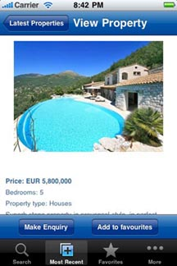
Marr said the idea is to enable users to shop as easily more than 300,000 properties listed on HomesGoFast.com in 70 countries, as checking their email. Marr said the app was aimed at making finding overseas property “extremely easy and convenient. And when you find the property of your dreams, you can make an enquiry direct to the sellers,” Marr added.
Marr founded HGF in 2003 and it has gained recognition as one of the most visited websites in the overseas property niche. The site lists properties offered by agents, developers and individuals covering the full spectrum of property types,“off plan real estate, condos, beachfront property villas, and luxury homes and city pads from all over the globe. Whether your searching for a real estate in Asia, Africa, North America, South America,Europe, and Australasia the app has it covered.” Said Marr.
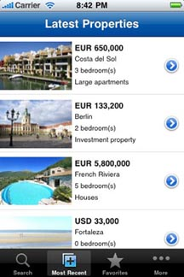
The exposure you receive as a seller when listing with Homesgofast.com includes its own network of overseas property websites and the global audience of iPhone users.
Homesgofast.com are using social media to help promote the app they are offering one lucky Twitter user the chance to win an iPod Touch, it's easy to enter, all you have to do is tweet a pre-defined message. By using twitter the company can pick one winner at random from a pre defined tweet
To enter simply click on the following linkhttp://clicktotweet.com/9Mb6f login to Twitter and then click the Tweet button, it's that simple! Terms and conditions found here
http://www.homesgofast.com/iphone-apps-property.php
Please see:
http://www.homesgofast.com/iphone-apps-property.php
Contact Details: Marr International Ltd
Cardinal Point
Park Road
Rickmansworth
Hertfordshire
WD3 1RE
UK
http://www.homesgofast.com
nick@homesgofast.com.
442030993392
~~~~~

Press release distributed via EPR Network (http://express-press-release.net/submit-press-release.php)

