South East Labels Re-Launches Cryogenic Label Line
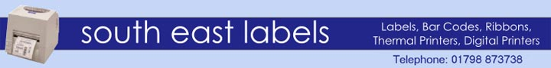

Released on: May 27, 2010, 06:02 am
Author: Jane Smith/ South East Labels
Industry: Computers
27th May, 2010 - South East Labels has recently decided to re-launch its cryogenic and anti-microbial label line that features improvements and cost reductions. This cryogenic label line has been specially designed for use under research and medical conditions that require exposure to the cryogenic temperatures of liquid nitrogen. Cryogenic and Anti-Microbial Labels
South East Labels has featured cryogenic labels in its product line for some time. These are special labels that use special adhesives and materials that can sustain adherence to surfaces at the freezing cryogenic temperatures of liquid nitrogen. Now is the time for a re-launch of its cryogenic line with an upgraded production process and new materials that allow them to offer new anti-microbial features.
The labels are traditionally supplied on rolls for use with thermal transfer printing devices although they can also be used on sheets in regular laser printers if a thermal printer is not available. Labels are frequently used on plain or pre-printer formats and can be supplied in any size and shape according to the individual specifications of the customer. For the latter, the company offers top-of-the-line machines that can take care of producing quality print jobs: the print-head resolution range for these machines is from 200 - 600 dots per inch (the latter particularly useful when high definition or very small text prints are required).
Innovation: Anti-Microbial Material
One of the most important selling points in this new line of cryogenic labels is the incorporation of anti-microbial material in the production process. This innovative material is based on the silver ion technology and has been developed to specifically target the needs of the pharmaceutical sector, though it is clear that it can solve the operational needs of any sector that requires hygienic labelling. The new material allows the company to produce labels that actively inhibit the growth of bacteria which, in turn, minimizes the risk of cross-contamination. So far, the material has boasted a very promising 99.99% effectiveness in inhibiting the growth of a wide range of harmful bacteria and funghi, including the likes of MRSA, E-Coli and Salmonella.
The Company: South East Labels
South East Labels is a company, with over 20 years of experience, that produces and distributes labels, barcode labels for barcode printing, digital printers, ribbons, label printers, security and asset-tracking labels, scanners, verifiers and more to a wide variety of industries.
Contact Details: 21 Wilbury Grove
Hove
United Kingdom
Jane Smith
Journalist Assistant
http://www.southeastlabels.co.uk/
~~~~~

Press release distributed via EPR Network (http://express-press-release.net/submit-press-release.php)

