Take the Spring and Summer On With Confidence and a Brand New Look


Released on: May 28, 2010, 2:11 am
Author: Transform Cosmetic Surgery Group
Industry: Healthcare
The Transform Cosmetic Surgery Group wants to ensure all Britons can get the most from the beautiful spring and summer weather with a full line of procedures to create soft, smooth, and healthy looking skin.
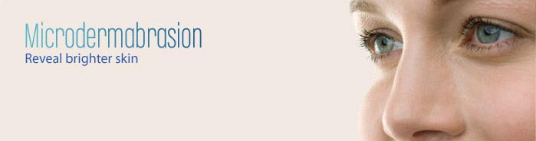
The effects of a harsh winter can be long-lasting, as the cold weather often leaves people with blotchy colour, texture, and dry skin. This leaves people with lower self-image, confidence, and just not as happy with their appearance and the revealing clothing as they should be. But now, Transform can eliminate these side effects and get everyone excited about the summer weather and all the benefits that come with it.
Facial Spring Cleanings
To get ready for warmer weather, facial peels are a great way to get rid of damaged surface layers of the skin so it looks great no matter how much of it you bare. This treatment removes the dead and damaged skin to leave behind nothing but firm, healthy looking skin. It can also help treat acne scars, wrinkles and uneven skin tone. Transform also offers this treatment in a number of different formulas to treat skin of all types so that everyone can enjoy fresh, new skin.
Get a Healthy Glow
Both sexes can achieve smooth skin and a healthy glow with microdermabrasion. This technique takes away the surface layers of skin to deeply exfoliate and increase skin cell renewal. It also reduces wrinkles, evens skin texture, and gives skin a healthy colour. With this treatment, skin is gorgeous and ready for great summer outfits in no time.
Hair-Free and Silky Smooth
Show more skin and wear your great summer outfits with a smile when skin is completely free of that pesky hair. Transform's new Quantum Intense Pulsed Light Laser removes hair on leg, arms, bikini lines and faces permanently and effortlessly.
To make sure everyone can get the most out of this year's beautiful weather, Transform Cosmetic Surgery Group is offering a series of deals for the spring of 2010:
Cosmetic Surgery Deals:
- Save £4 on a course of facial peels
- Save £55 on 2 for 1 microdermabrasions
- Save £200 or more with buy one get one half price hair removal
For more information, please call Helen Pickerill or Heather
Kenny at Brazen PR on T: 0161 923 4994 or E: transform@brazenpr.com
~~~~~

Press release distributed via EPR Network (http://express-press-release.net/submit-press-release.php)

