Topshop Make Up Is Here

Released on: May 10, 2010, 12:43 pm
Author: Topshop
Industry: Retail
On Wednesday 5th May Topshop launched its first very own make-up range; containing all the must have make up essentials for SS10.
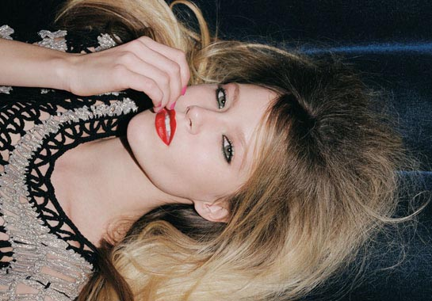
The full collection comes in two parts and will be refreshed twice a season; a Core Collection of first class beauty essentials as well as a capsule Trend Collection of directional hues, both embody the bold and innovative essence of Topshop.
With its first make up range, Topshop has ensured its cosmetics encapsulate the Topshop spirit, by formulating it with a mixture of directional colours and seasonal collections. Inspired by a World Tour, Topshop have injected their knowledge of trends, colours and textures to create an original fresh approach to make up.
Topshop has teamed up with top make-up artist Hannah Murray; renowned for her work on the catwalks in some of London’s most influential fashion houses to help launch the new range. The two last collaborated when Murray worked on the AW10 Unique show, hosted by Topshop at London Fashion Week in February 2010.
To celebrate the May launch, Topshop is partnering with TAAZ.com, to launch its new Online Makeover tool. The tool will allow customers to digitally 'try on' a variety of preloaded photos - or upload their own photos - to see what product best suits them for the complete Topshop makeover.
Kate Walmsley, Head of eCommerce for Topshop, comments: “We wanted our customers to be able to interact and play with Topshop Make Up online. The quality of the TAAZ.com virtual makeover tool and the ability to customise the experience to reflect the Topshop brand made them the perfect partner. It’s so much fun, it had all the girls at Topshop HQ instantly addicted!”
About Topshop:
Topshop was established in 1964 and is part of Arcadia Group Ltd. Sir Philip Green became owner of Arcadia Group Ltd in 2002.
Topshop is continually recognised as being an authority on women's fashion, having won several awards for it’s design reputation and new services, and has a wide range of clothing from women's jeans and maxi dresses to maternity wear.
Topshop was the first fashion retailer to show on schedule at London Fashion Week in September 2005 when it presented its own acclaimed in-house design collection Unique (created in 2001). Subsequent partnerships with international boutiques as far flung as Tokyo and LA followed and Topshop continues to grow its reputation for supporting exciting new talent.
For further media information please contact:
Liz Shuttleworth
Press Officer
Press Office
Arcadia Group Ltd
70 Berners Street
London
W1T 3NL
020 7927 1484
www.topshop.com
~~~~~

Press release distributed via EPR Network (http://express-press-release.net/submit-press-release.php)

