With The Election Out Of The Way...
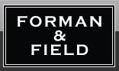
Released on: May 31, 2010, 07:01 am
Author: Jane Smith
Industry: Food & Beverage
London, 31 May, 2010: Now that the UK general election has been and gone, it's time to think of something other than politics. Yet politics have always gone hand-in-hand with a few porky pies, so it's perhaps apt to turn our focus to more gastronomic issues.
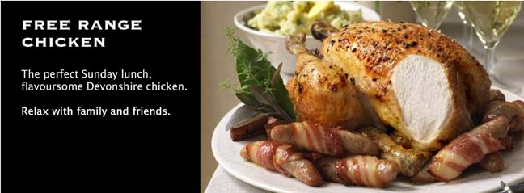
Traditional British Pork Pies are one of life's simple pleasures, and Forman & Field provide the solution for those looking for some of the highest quality local produce. Widely regarded as the country's leading supplier of fine food by mail order and online, Forman & Field stocks Traditional Pork Pies from Norfolk made by Silent Partners from gloriously tasty pure breed Old Spot Rare Breed porkers. These handmade traditional pies are perfect for a cold lunch or starter. Another choice recommendation for fans of good ol' fashioned porky pies is Mrs King's Pork Pies: genuine, thoroughbred Melton Mowbray pork pies.
Speaking of simply delicious pies, pie addicts are sure to go pie-eyed over Forman & Field's range of Simple Simon's Pies. Made with the freshest, natural ingredients on shredded potato encased in flavoursome pastry by chef Bernard Alessi, these pies come in a wide variety of new and exciting flavour combinations. The value-for-money Best Sellers Selection Pack contains 1 x Organic Beef & Mushroom, 1 x Chicken and Tarragon, 1 x Smoked & Fresh Haddock with Creamy Leeks.
Forman & Field, launched in 2002, is considered by top food writers as the country's leading supplier of fine food by mail order and online. The company is regarded to be a pioneer in quality seasonal British Foods, including such delicacies as three-bird roast, fine ham, cheese and desserts, such as culinary masterpieces from Nadell's chocolate cake selection.
Forman & Field's parent company, H. Forman & Son was founded in 1905 by Harris Forman, great-grandfather of present owner, Lance Forman. Regarded to be the UK's oldest and best-known salmon smoker, H. Forman & Son is the choice of top chefs and hotels in London and around the world, including the Dorchester, Sandy Lane, Barbados, Fortnum & Mason, and Waitrose.
About Forman & Field: Forman & Field was established in 2002 as a national home delivery service for private customers wanting to order H. Forman & Son's fish as well as gourmet foods from other speciality producers. They are widely regarded as the country's leading supplier of fine food by mail and online order.
Forman's is also noted for Forman's Fish Island, a brand new corporate event and party venue with unrivalled Olympic views and outdoor terraces, and Forman's Restaurant, which opened to the public in February 2010. It seats 50 with views across the River Lea to the Olympic stadium. Executive Chef Lloyd Hardwick, original Executive Chef of the Tate Modern restaurant, serves modern British food there including a special Forman's salmon tasting menu.
Contact Details: 21 Wilbury Grove
Hove
United Kingdom
Jane Smith
Journalist Assistant
http://www.formanandfield.com/
~~~~~

Press release distributed via EPR Network (http://express-press-release.net/submit-press-release.php)

