npower Launches New Wallace & Gromit Ad - Hand Of Dog


Released on: May 13, 2010, 6:36 am
Author: npower
Industry: Energy
While many England fans still bear the scars of the fateful game where Maradona proclaimed that the 'Hand of God' knocked England out in 1986, Wallace and Gromit exact their revenge in the new npower TV ad.
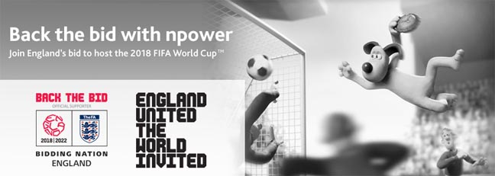
The new TV ad supports the Back the Bid 2018 campaign for England to host the FIFA World Cup(TM). As an official supporter of the bid npower is getting behind England 2018, as hosting the World Cup would provide a huge boost for British businesses large and small.
In one of the funniest football ads to be shown on British TV for many years, Wallace & Gromit, the eternal entrepreneurs, are all set to profit from a tournament in England with their madcap pie-making business - "WAG's Pies Ltd". As usual, their best-laid plans are threatened when Wallace's latest invention - a pie-delivery machine - threatens the game with an errant pie.
Gromit sprints through the stands and onto the pitch making a leap for the runaway pie. As he flies through the air and catches hold of the pie, his other paw accidentally makes contact with the football sending it hurtling past the goalie and into the goal.
The advert ends with Wallace smugly viewing the success of his small business venture and Gromit enjoying a read of the local rag. The front page carries a photo of a very familiar dog scoring a goal under the headline "Hand of Dog".
The new advert was created by the agency VCCP and Aardman Animations. The 30 second format will be shown on national television. There is also a 40 second clip available exclusively online that features the unforgettable and original 1966 script and voiceover, which declares "They think it's all over...it is now."
Kevin Peake, marketing director at npower, commented: "We believe a successful bid to stage the FIFA World Cup(TM) in England would be fantastic for the country and particularly for Britain's businesses. We're already committed to helping our business customers save money by saving energy; Wallace & Gromit illustrate, in their fun and endearing way, how hosting the FIFA World Cup(TM) in 2018 could also benefit businesses' revenue."
The advert is part of an exclusive npower series of animations created by Aardman Animations.
Lucy Wendover, Marketing Manager at Aardman, said: "We have enjoyed working on thenpower adverts so far which focus on Wallace & Gromit's approach to energy efficiency, but it's been especially exciting for us to take them into the world of football and, as usual, see Gromit saving the day."
npower's Back the Bid campaign is part of its role as an 'Official Supporter' of the England 2018 FIFA World Cup(TM) hosting bid.
About npower:
npower is one of the UK's largest electricity suppliers and has 6.8 million customer accounts across the UK.
npower sponsors the Test Match Series in England, Women's Test Series and the Village Cup.
npower has been awarded platinum status in Business in the Community's CR Index and is one of twenty-nine companies to have achieved the CommunityMark since its launch. All CommunityMark achievers have been recognised for demonstrating excellence in their holistic and strategic approach to community investment.
For further information, interviews and images please contact:
Ben Dobson
Resonate Communications Ltd
5th Floor Holborn Gate
330 High Holborn
London
WC1V 7QG
020 7861 2525
~~~~~

Press release distributed via EPR Network (http://express-press-release.net/submit-press-release.php)

