Charity Golf Outing Planned To Help Fight Child Abuse
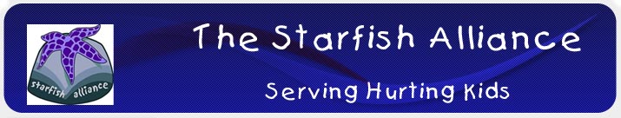

Released on: June 07, 2010, 2:31 am
Author: The Starfish Alliance
Industry: Non Profit
Columbus, OH, June 7, 2010 – The Starfish Alliance will hold its annual golf outing on Saturday, July 10 at Bent Tree Golf Club, 350 Bent Tree Road in Sunbury. This event will help continue its support of Royal Family Kids' Camps of Dublin (RFKC). RFKC provides a free one-week residential summer camp to hurting children, ages 7 to 11, from the Franklin County foster care system.
The golf match is open to the public.
Registration begins with lunch at noon followed by a modified shotgun start at 1:30 p.m.
Registration is $75 per golfer and includes 18 holes of golf, riding cart, lunch, dinner, and various awards. Additional tickets for drinks, mulligans, and a chance at the MILLION DOLLAR SHOT will be available for purchase the day of the event.
“This event is, of course, lots of fun,” said Steve Fox, Executive Director of The Starfish Alliance. “But more importantly, it helps RFKC create a week of positive memories for abused, abandoned, and neglected kids who otherwise might not have the opportunity to attend a summer camp.”
Business sponsorships are also available for holes, events, and trophies.
Though players may register at the golf course on the day of the event, early registration is recommended as there is a limit on the number of players.
Reservations may be made by calling Brian Osborne at 614.305.5170 or via The Starfish Alliance website, www.starfishalliance.org.
About The Starfish Alliance :
The Starfish Alliance is a 501(c)(3) public charity whose goal is to financially support services for children who have been left behind. Children who many people have simply abandoned. Children who need to know that someone really does care about them.
Our mission statement is straightforward – Education and Advocacy: serving hurting children and their parents.
Contact:
Stephen L Fox, Executive Director
The Starfish Alliance, Inc.
614.305.5115
www.starfishalliance.org
~~~~~

Press release distributed via EPR Network (http://express-press-release.net/submit-press-release.php)

