EXDYSIVITY - New Management Concept Helps Businesses Self-Reform

Released on: June 04, 2010, 4:06 am
Author: Yanyong Thammatucharee
Industry: Management
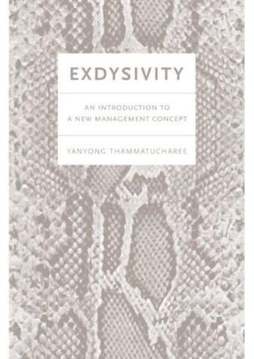
Bangkok, Thailand – June 4, 2010 - The new economy needs a new philosophy. Readers can find that in EXDYSIVITY: AN INTRODUCTION TO A NEW MANAGEMENT CONCEPT. “Old” business practices are becoming obsolete, yet companies and employees are still shackled to them, sticking to a black and white numbers mentality and ignoring the implications of the non-financial. This non-flexibility is a real threat to the survival of businesses everywhere.
But Yanyong Thammatucharee, in EXDYSIVITY, explains how to transform a business into a highly adaptive member of the world. This management plan not only helps a business today, but outlines how to ensure long-term survival. This revolutionary guide explains how adherence to key performance indicators can adversely affect team performance, how archaic back-office functions keep a business from thriving in the twenty-first century and what role corporate responsibility plays in the success of a business. It even explains how to look at standard accounting practices differently. If productivity is required for better cost position, EXDYSIVITY is necessary for systemic reform of businesses in the 21st century.
Author Thammatucharee has 20-plus years experience in finance and accounting for a number of major firms, and currently is senior vice president of accounting and finance for a Thai group of retail and marketing firms. His experience brings the unique perspective that created EXDYSIVITY. His philosophy is not only a business management plan, but a life management plan. It starts in the mind and is an organic process. He explains it best in this excerpt from the book: “Understanding the exdysivity process can give an organization a chance to exist. It’s not a long process, but it is a continuous one that requires being alert and facing up to any new challenges we have to face every day.”
EXDYSIVITY is available only at Amazon.com. To contact Mr. Thammatucharee, please e-mail him at yanyong.thammatucharee@gmail.com
Contact Information:
Yanyong Thammatucharee
www.controllerfocus.com
yanyong.thammatucharee@gmail.com
9/3 Vista Park, Samakkee Road, Pakkred, Nonthaburi, Thailand
~~~~~

Press release distributed via EPR Network (http://express-press-release.net/submit-press-release.php)

