Face Of Debenhams' Designer Collaboration H! By Henry Holland Swim Revealed


Released on: June 04, 2010, 1:49 pm
Author: Debenhams
Industry: Retail
Henry Holland commented, "Fiona caught my eye immediately with her entry for our original 'Find a Face' competition. She looks lively, happy and fun so I thought she'd be the perfect girl to represent the new H! swim range."
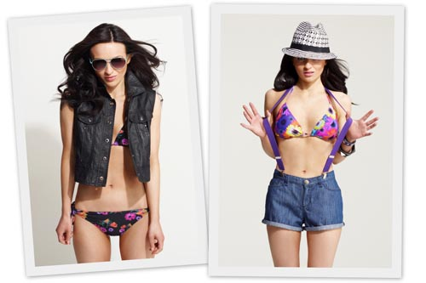
Fiona entered a competition to have her face included in a one-off print designed by Henry Holland and used on a handbag and scarf in the Autumn H! by Henry Holland range. Henry was impressed with Fiona's entry and decided to approach her to model his high summer swim range.
Sasha Nagalingham, swimwear buyer at Debenhams, said, "At 5'4" Fiona might not meet traditional criteria for a professional model, but she is beautiful, a natural on set and has a great personality – she’s someone the H! customer will really relate to.
"Looking at the images she produced, you wouldn't think for a moment Fiona had never set foot in front of a camera."
Fiona Kennedy, said, "I was a little dazed when I got the call - it was completely unexpected. I've never done anything remotely like this before.
"I'm a secret nerd, with a naturally small frame and never in a million years would I have thought I'd be modeling swimwear, especially for such big names like Henry Holland or Debenhams.
"On the day, I was extremely nervous, but after a couple of hours I just let my hair down and got in to the swing of things - it ended up being so much fun"
Fiona has written a blog for Debenhams about her day, what she thinks of the collection and how she feels about being spotted by Henry Holland.
The Henry Holland range includes bikinis and cut-out swimsuits in eye-catching photographic floral prints complimented by cute dresses and pinafore cover up pieces.
The H! by Henry Holland high summer swim and holiday collection has been specifically designed to appeal to the 17 - 25 year old age range and is a young designer fashion brand that translates the House Of Holland brand to the high street.
Like all Debenhams' designer collaborations, H! by Henry Holland will be a permanent feature within the department store. The collection is priced from £5 to£60.
Debenhams launched the designer fashion collaboration concept in Autumn 1993, something that is much imitated today. The retailer still differs from much of the high street as these partnerships are a permanent addition to its offer.
About Debenhams:
Debenhams is a leading department stores group, and has a strong presence in key product categories including womens fashion, with dresses, womens shoes, bikinis, jeans, mens clothing, home ware, make-up, health and beauty, accessories, perfume, lingerie and children's wear.
Today Debenhams offers the country's best known design talent including J by Jasper Conran, Star by Julien Macdonald, Rocha. John Rocha, Betty Jackson. Black, Floozie by FrostFrench, Butterfly by Matthew Williamson, Pearce II Fionda, BDL by Ben De Lisi, Reger by Janet Reger, Pip Hackett, Beach by Melissa Odabash, EB by Erikson Beamon, Van Peterson 925 and Grey Rose by Jane Packer.
Further press information:
Carie Barkhuizen
Debenhams Press Office
33 Wigmore Street
London
W1U 1QX
0207 529 0236
www.debenhams.com
~~~~~

Press release distributed via EPR Network (http://express-press-release.net/submit-press-release.php)

