First Nations Announces Historic Opportunity for Tribal Philanthropy
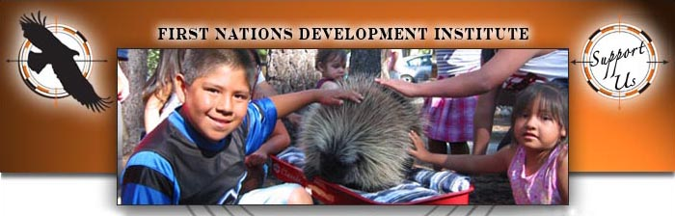

Released on: June 03, 2010, 5:25 am
Author: First Nations Development Institute (First Nations)
Industry: Non Profit
June 3, 2010 - Longmont, CO - First Nations Development Institute (First Nations) is proud to announce that tribal philanthropy, the oldest form of philanthropy in the United
States, has gained an equal voice in mainstream philanthropy by being welcomed as full, voting members of the Council on Foundations. It is a crucial moment for Indian Country to be awarded full membership to the Council. It will allow Native communities and grantmaking organizations to help steward the strategic direction of mainstream philanthropic efforts, including directing how funding reaches and impacts American Indian people.
As sovereign nations, many tribal governments operate charitable giving programs that benefit not only Native communities, but also local, regional and national organizations. Since less than one-half of one percent of private foundation grants are given to address American Indian issues, tribes and Native organizations have stepped forward to design their own philanthropic models to address vast needs in Indian Country. First Nations alone has provided more than $25 million in grants to protect assets in Native communities, while honoring the sovereignty of tribal governments.
"At First Nations, we believe that tribal philanthropy operates from a culturally-based voice of strength, assuredness and accomplishment. We believe that this is where American Indians must and will exist in America's philanthropic reality," said Michael E. Roberts, president of First Nations. Roberts also shared, "American Indian people deserve an equal seat and vote at the philanthropy table with mainstream grantmakers. We are grateful to the Council on Foundations for partnering with us to make this a reality."
The Council on Foundations also shared their response to welcoming tribal philanthropy as full members, "We are grateful to our partners, including the First Nations Development Institute, who devoted much of their time and energy in making this possible, and to our board for ensuring that the Council's policies addressed the unique aspects of tribal philanthropies," said Steve Gunderson, president and CEO of the Council on Foundations. "This policy change reflects our commitment to supporting diverse and inclusive philanthropy in all of its forms."
About the Council on Foundations
The Council on Foundations, formed in 1949, is a nonprofit membership association of grantmaking foundations and corporations. Members of the Council include approximately 2,000 independent, operating, community, public and company-sponsored foundations and corporate giving programs in the United States and abroad. The assets of Council members total more than $307 billion. The Council's mission is to provide the opportunity, leadership, and tools needed by philanthropic organizations to expand, enhance, and sustain their ability to advance the common good. For more information, visit the Council's website at www.cof.org.
About First Nations Development Institute
For thirty years, using a three-pronged strategy of Educating Grassroots Practitioners, Advocating for Systemic Change, and Capitalizing Indian Communities, First Nations has been working to restore Native American control and culturally-compatible stewardship of the assets they own - be they land, human potential, cultural heritage, or natural resources - and to establish new assets for ensuring the long-term vitality of Native communities. First Nations serves rural and reservation-based Native American communities throughout the United States. For more information about First Nations Development Institute, visit www.firstnations.org.
###
Contact Details: Vicky Stott
703 3rd Ave, Suite B
Longmont, CO 80501
303-774-7836 Phone
303-774-7841 Fax
vstott@firstnations.org
www.firstnations.org
~~~~~

Press release distributed via EPR Network (http://express-press-release.net/submit-press-release.php)

