House Of Fraser Introduces Peter Werth Online


Released on: June 10, 2010, 03:50 am
Author: House of Fraser
Industry: Retail
House of Fraser has announced the introduction of the new spring/summer collection from Peter Werth online.
Established in 1975, Peter Werth started off as a specialist in knitwear and became a brand that prided itself on innovative design of the highest quality and great style.
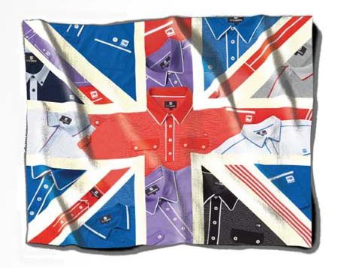
Peter Werth is currently available online at houseoffraser.co.uk. The brand has now grown into one of the most passionate and respected British brands around. House of Fraser offers a comprehensive smart/casual Peter Werth menswear collection online that
combines wearable styles with the latest trends.
The Peter Werth collection enters this season with an artisan influence. The use of soft, more fluid fabrics in tonal greys and lilacs give the Peter Werth collection a draped, layered look. Ultra fine knitwear and compact coated cottons are layered over lightweight jersey and vintage circus graphic tees. Oyster, slate and stone are complemented with azure and lilac bold floral print shirts. The Jersey polo is a key piece for this season's summer wardrobe and has been trimmed with striped cotton and button detailing.
For the peak summer months, shoppers will find that Peter Werth clothing has moved from soft, fluid fabrics to a laundered, lived in look. Unlined cotton blazers are worn with retro Hawaiian print or check shirts. Gingham bucket hats and straw trilby’s are the perfect finish to the high summer look and all garments are signed off with passport print branding. Customers can shop online at houseoffraser.co.uk to find their favourite summer pieces from the Peter Werth collection.
Customers who seek bespoke tailoring for Spring Summer will find Peter Werth's collection offers formalwear that has a lighter feel, with new fabric introduced for high summer. Three piece options return in abundance and are updated with new trims and finishes.
The Peter Werth collection is currently available online at houseoffraser.co.uk.
ENDS
About House of Fraser
House of Fraser is a department store group with 61 enviable locations across the UK and Ireland and a fully transactional website. As one of the best known names on the high street, House of Fraser has presented customers with an unrivalled nationwide department store for more than 160 years. The company was acquired by the Highland consortium in November 2006 marking the beginning an exciting new chapter in its history. The group has annual sales in excess of £1.25bn and employs 6,500 House of Fraser staff and 10,000 concession staff through 5 million sq ft of selling space. House of Fraser also stocks Peter Werth t shirts and other men's designer clothing by big brands.
House of Fraser media contact:
Rea Shahroudi
Online Acquisitions Manager
House of Fraser
27 Baker Street
London
W1U 8AH
020 7003 4102
www.houseoffraser.co.uk
~~~~~

Press release distributed via EPR Network (http://express-press-release.net/submit-press-release.php)

